SMT
Coxswain Deck
Knowledge Assessment Watchkeeping
(Closed book)
Marking Sheet

Note for assessors
The answers in this marking sheet are comprehensive and technically correct.
A course participant is not expected to provide answers to that level of detail. Instead, for a satisfactory response, the participant’s answers should be within the range of model answers provided and indicate a basic level of knowledge and understanding of the topic.

Watchkeeping
- When two (2) vessels are approaching one another, a risk of collision can exist when.

- The distance of approaching vessel is closing.
- The compass bearing of approaching vessel is steady.
- An appreciable bearing change is evident when approaching a large, close vessel.
- All of the above

- Two (2) power-driven vessels are crossing and there is a risk of collision.

Draw the actions for each vessel to avoid collision.

B
A

Who is the stand-on vessel.
Vessel B

What is the action of the give-way vessel.
Make bold and early turn to starboard-Pass behind vessel ‘B’

- Vessel ‘A’ is overtaking Vessel ‘B’.
Draw which way Vessel ‘A’ can overtake Vessel ‘B’.
Vessel ‘A’ can overtake Vessel “B”.

- Portside only
- Starboard side only.
- Either side (Pending safe navigation)
What action shall Vessel ‘B’ take whilst being overtaken.
Maintain course and speed, observe other vessel to ensure safe navigation
- In a distress situation, list THREE ways you would raise the attention of another vessel within sight.
Range of answers can include: pyrotechnics – rocket (parachute) flares, smoke signal; slowly raising and lowering arms; square flag with ball above or below; code flag N over C; sound signals – continuous sounding of fog horn or signalling device, explosive signal at intervals of 1 minute; radio, smouldering bucket
Answer should not include EPIRB – this does not attract attention of other vessel
- On which side of this Cardinal Mark is safe water.
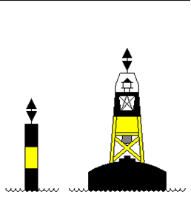

North East South West

- Describe the light and flashing characteristic of an Isolated Danger Mark
Colour White
Flashing Flashing (2)

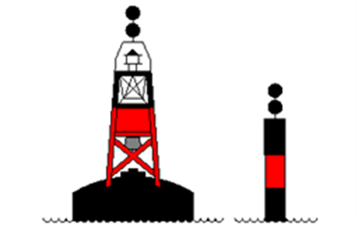

- When leaving Harbour, which side of your vessel should you keep this mark.

Port 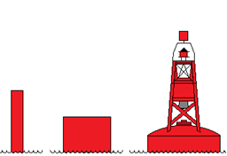 Starboard
- Using the chart provided, draw a safe route from Position A to Position B.

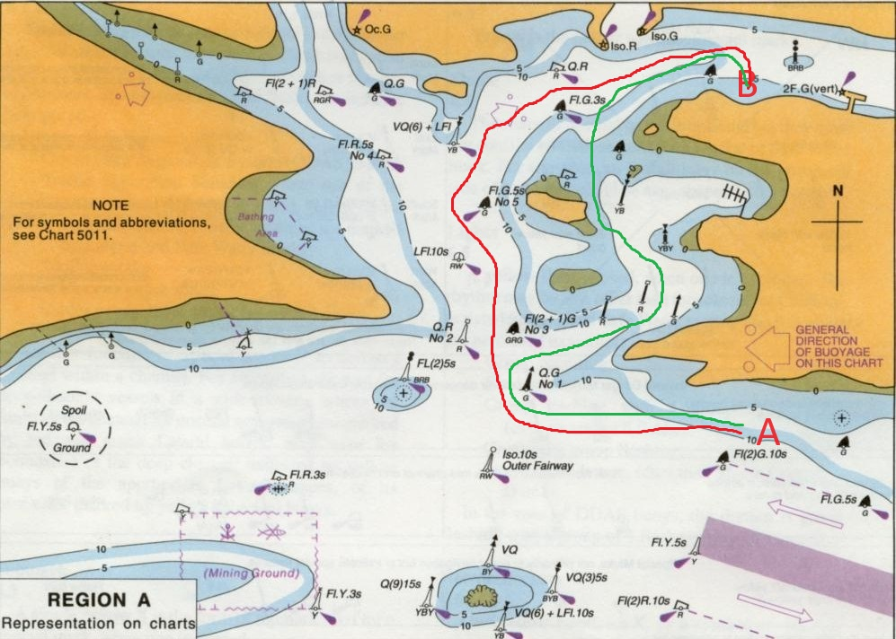
- When determining a safe speed for your vessel, list 5 factors the Colregs require you to consider.

(i) The state of visibility;
(ii) the traffic density including concentrations of fishing vessels or any other vessels;
(iii) the manoeuvrability of the vessel with special reference to stopping distance and turning ability in the prevailing conditions;
(iv) at night the presence of background light such as from shore lights or from back scatter of her own lights;
(v) the state of wind, sea and current, and the proximity of navigational hazards;
(vi) the draught in relation to the available depth of water.

